Name: Aditya Matale

Class: AIDS-B

Roll No: 25

-----------------------------------------------------------------------------------------------------------------------

BASIC AND ADVANCE LINUX COMMANDS

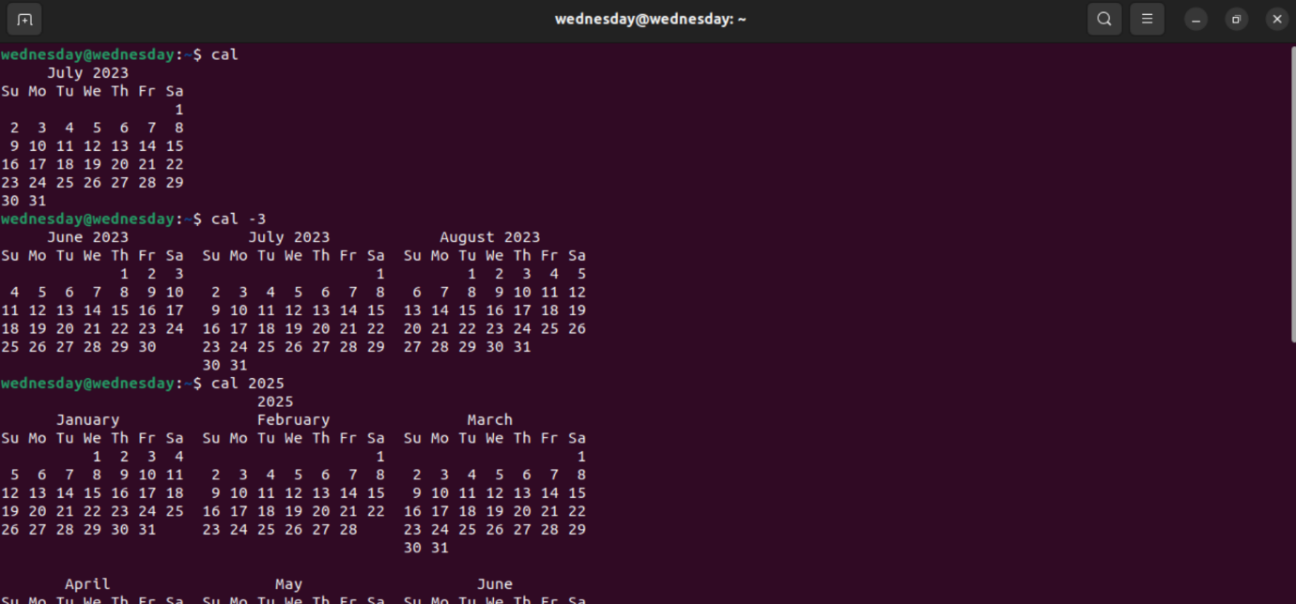

**cal**: To display the current month's calendar.

**cal -3**: You can see the current month's calendar, as well as the previous month and the next month, side by side.

**cal 2025:** This will show the calendar for the entire year 2023.

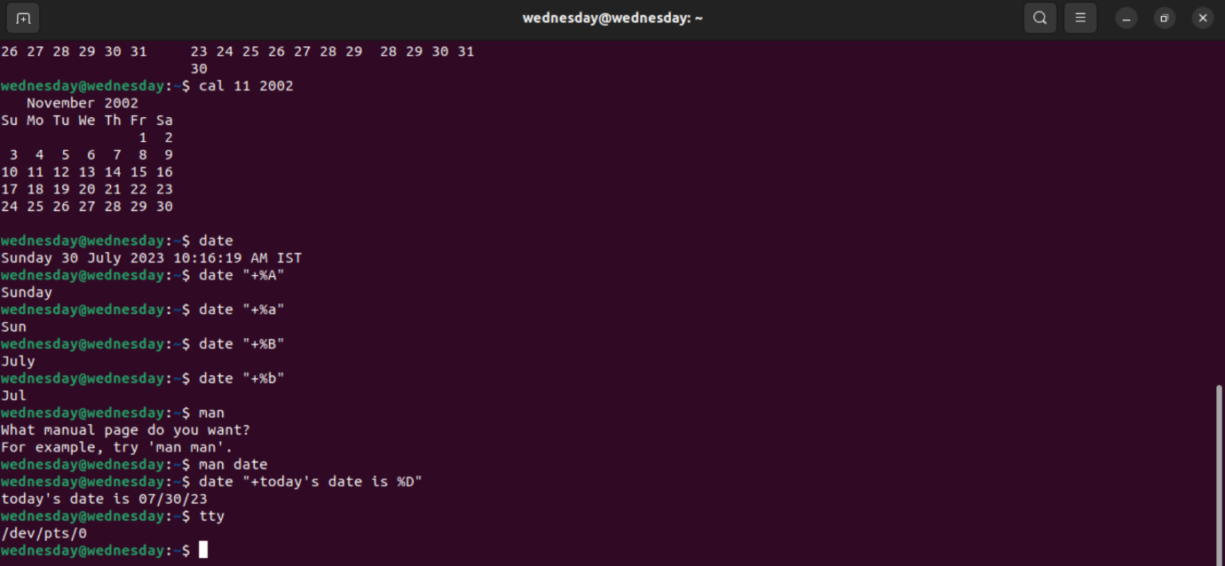

**cal 11 2002:** This will show the calendar for July 2023.

**date:** To display the current date and time.

The date command also supports various format specifiers that allow you to customize the output according to your needs.

**“+%A”** - Displays the current day of the week.

**“+%a”** - Represents the abbreviated day of the week.

**“+%B”** - Displays the current month.

**“+%b”** - Represents the abbreviated month.

**man:** To display the manual page for a specific command.

**tty:** This command provides a quick way to identify the terminal device associated with the current shell session.

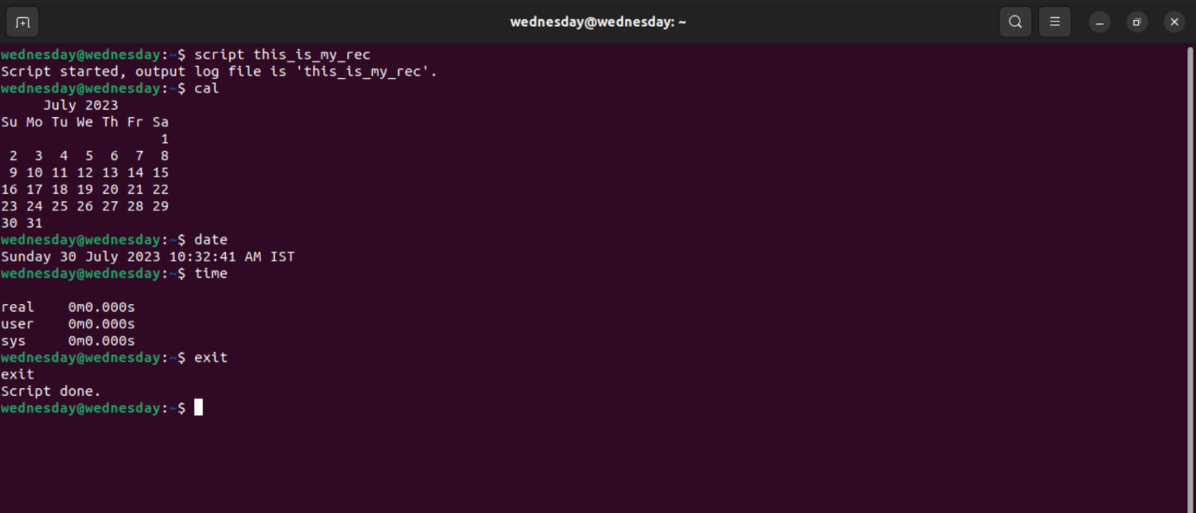

**script:** Records a terminal session and stores it into a file.

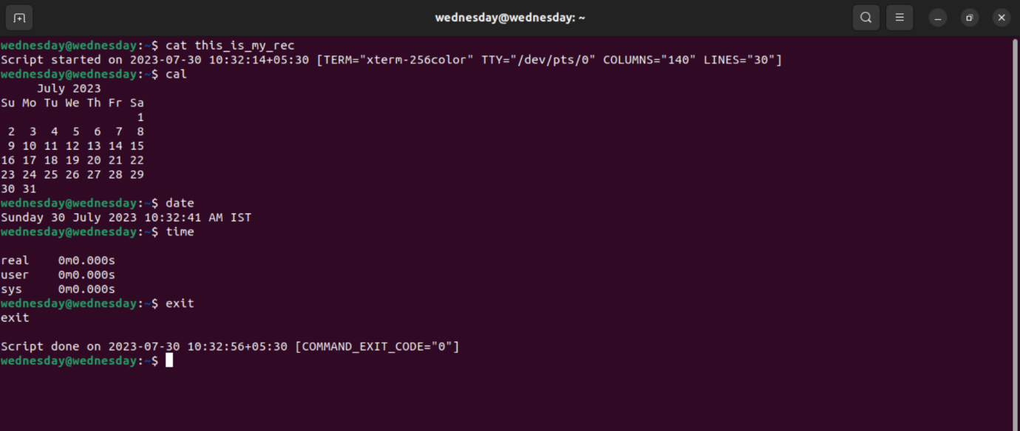

**cat:** Displays the content of a single file.

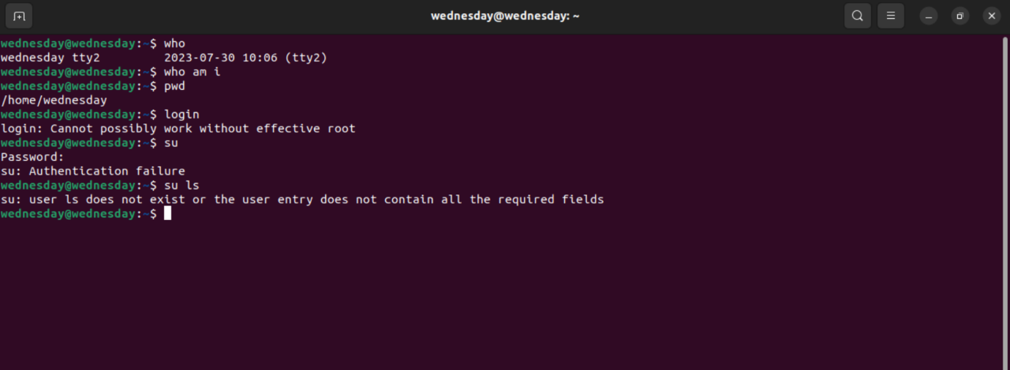

**who:** Display the list of currently logged-in users.

**whoami:** It will output the username of the current user.

**login:** To start a new login session on the system.

su: To switch to the root user account.

ls: List files and directories in the current working directory.

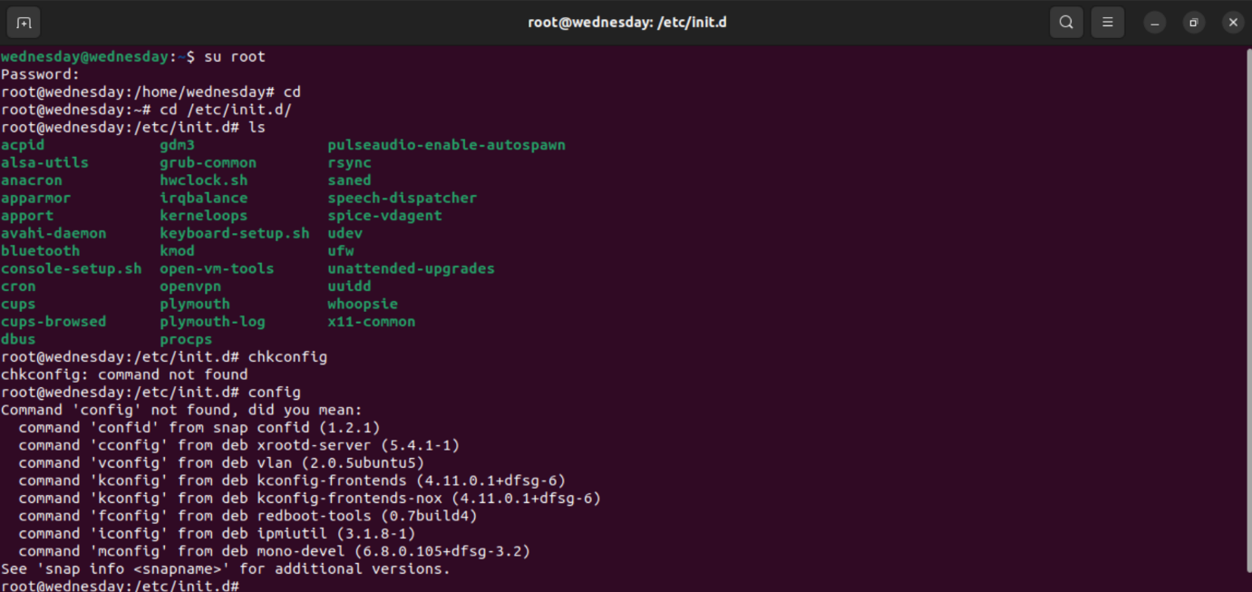

chkconfig: To manage the services that start automatically at system boot time.

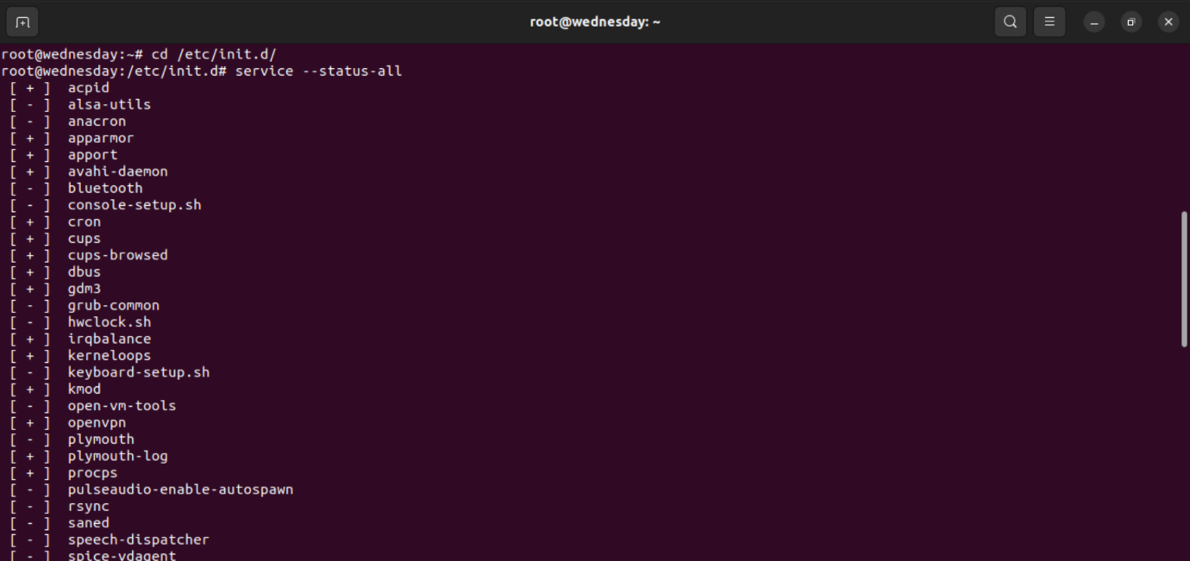

service: To interact with system services managed by the SysV init system.

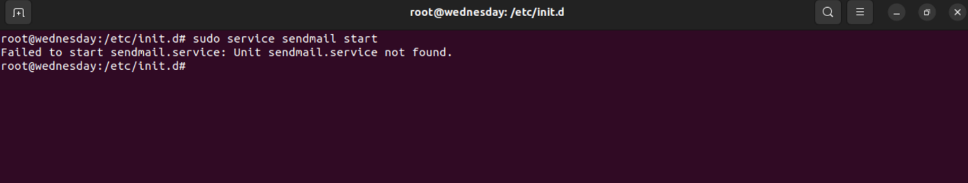

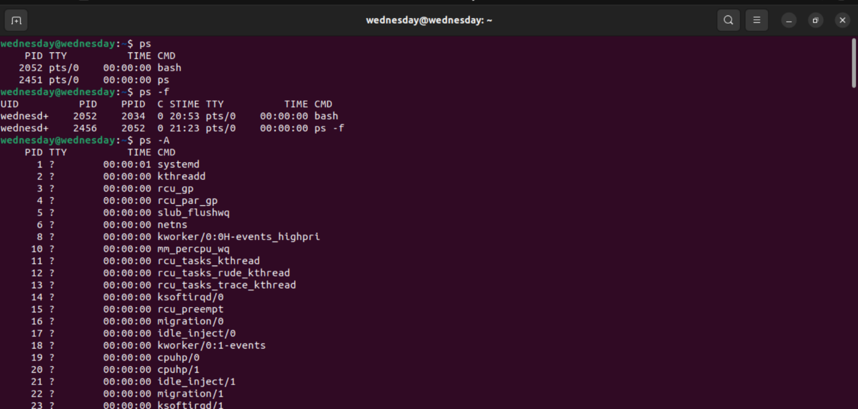

ps: Display information about processes owned by the current user.

ps –A: It will show a list of all processes currently running on your system, including those started by different users and daemons.

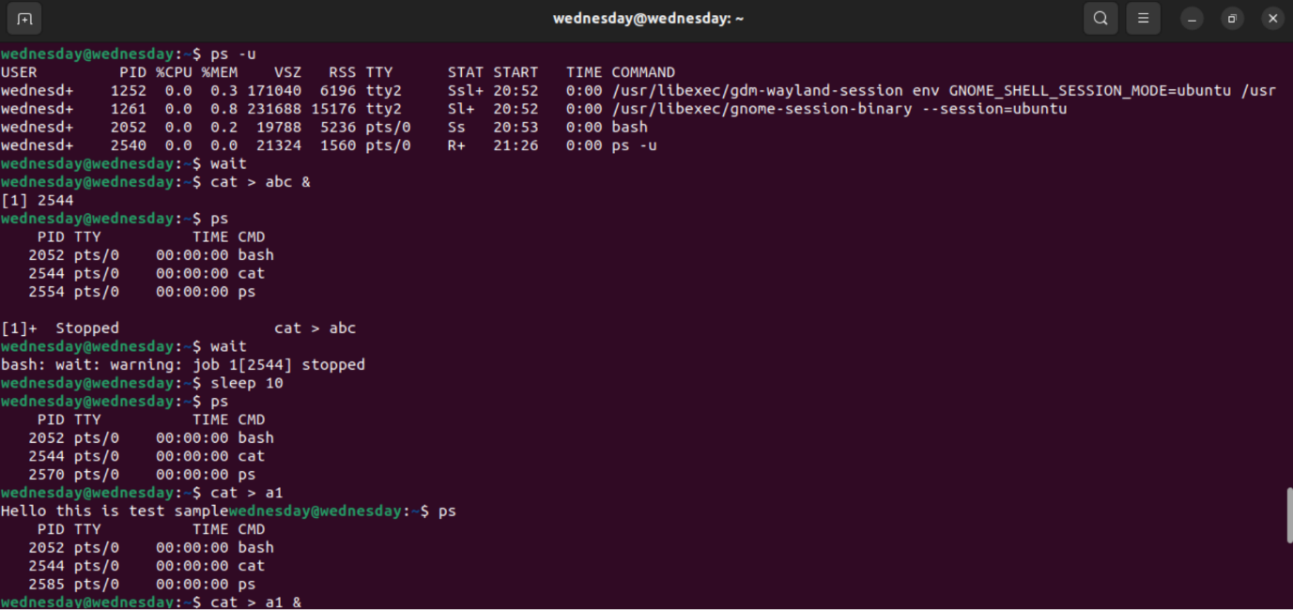

ps -u: Display processes owned by a specific user.

wait: To pause the execution of a shell script until all background processes or jobs are completed.

sleep: To suspend the execution of a script or shell command for a specified amount of time.

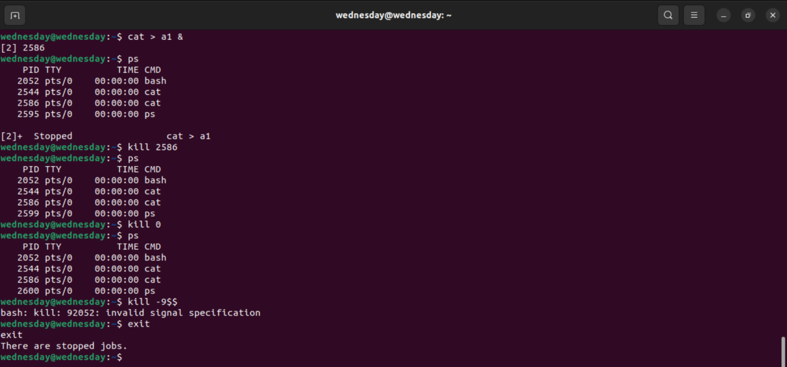

kill: To send a signal to one or more processes, allowing you to terminate or manipulate their behaviour.